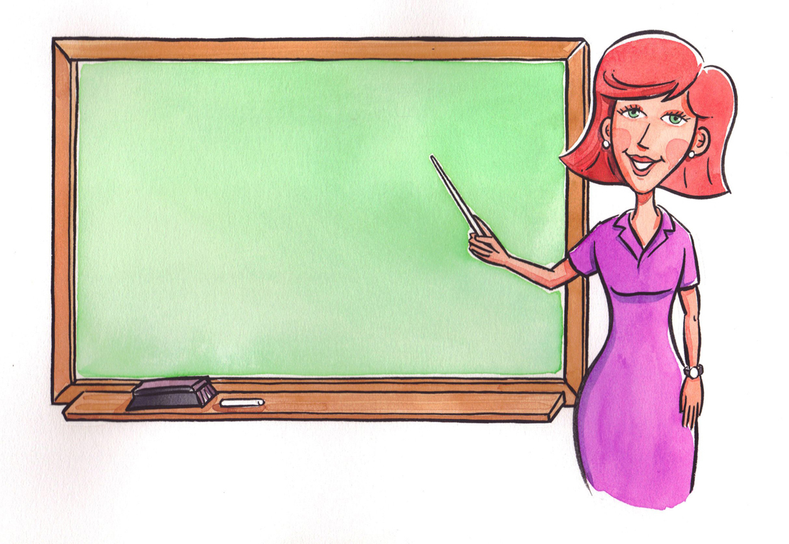
Professional Development

All staff will complete the required hours of training and maintain all required training according to the State of Iowa Standards. If a staff member fails to complete or maintain their required educational training (as outlined below), they will forfeit their potential merit raise and their holiday pay if their training is not completed upon their annual evaluation date (Based on the employees’ date of hire). FAILURE COULD ALSO RESULT IN TERMINATION.

- SING (IOWA) RECORD (Criminal history & Abuse registries) Renew every 2 years.

- FBI NATIONAL FINGERPRINT Submitted to DCI Renew every 4 years.

- FIRST AID CERTIFICATION Required within first 3 months of employment & maintain.
- CPR CERTIFICATION Required within first 3 months of employment & maintain.

- UNIVERSAL PRECAUTIONS TRAINING
At least 1 hour required within first 3 months of employment and annually thereafter.

- MANDATORY CHILD ABUSE REPORTER TRAINING
Within first 3 months of employment and every 3 years thereafter.

- PHYSICAL EXAM – within 6 months prior to hire and every 3 years thereafter.

- ESSENTIALS TRAINING – 12 MODULES Required within first 3 months of
Employment.

- STAFF TRAINING – TOTAL HOURS
(10 hours required first year of employment, 6 hours annually thereafter)

Signature:_______________________________ Date:________________________

Supervisors
Signature: _______________________________ Date: ________________________

