N
A
N
N
I
E
S









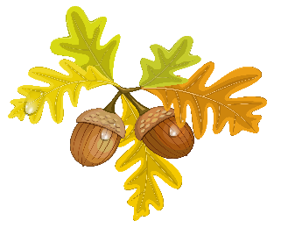

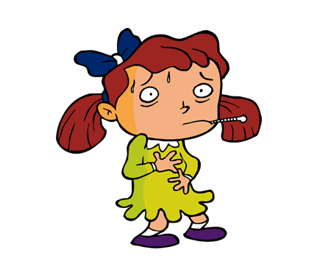
SEPT/OCT/NOV/DEC 2026

So, how can you help keep your
child from getting
the Flu?

Although there is no guaranteed way, including the vaccine, to prevent anyone from getting the flu, the simplest way is to avoid large crowds. As we all know this is almost impossible to do, so the next best thing is hand washing which helps prevent the spread of infections like the flu.

Although the flu season is typically from November to April, most cases occur between late December and early March with the vaccine offered between September and mid-November (however the shot can be given at other times of the year). Getting the shot before the flu season is in full force gives the body a chance to build up immunity to, or protection from, the virus. You can get a flu shot well into the flu season; it is best to get it earlier rather than later. Be sure to check with your physician to make sure this vaccine is necessary.
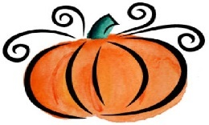

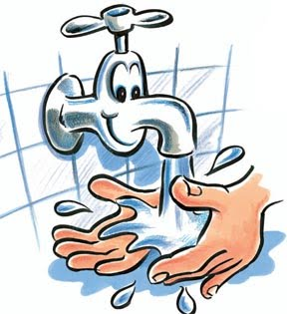

"Did you wash your hands?"
How many times did you hear that today? Probably a lot. But why are adults so hung up on hand washing? Why are they so in love with lather?
Washing your hands is the best way to stop germs from spreading. Think about all of the things that you touched today - from the telephone to the toilet. Maybe you blew your nose in a tissue and then went outside to dig around the dirt. Whatever you did today, you came into contact with germs. It's easy for a germ on your hand to end up in your mouth. Think about how many foods you eat with your hands.
You can't wear rubber gloves all day long, but you can wash your hands so those germs don't get a chance to make you or someone else sick. When germs go down the drain, they can't make anyone sick.
So, when are the best times to wash your hands?
- before eating or touching food (like if you're helping cook or bake, for example)
- after using the bathroom
- after blowing your nose or coughing
- after touching pets or other animals
- after playing outside
- after visiting a sick relative or friend
Now you have the when and the why of hand washing. But did you know that a lot of people don't know how to get their paws perfectly clean? The next time you're told to step up to the sink and scrub up, remember these handy hints:
- Use warm water (not cold or hot) when you wash your hands.
- Use whatever soap you like. Some soaps come in cool shapes and colors or smell nice, but whatever kind that gets you scrubbing is the kind you should use. Antibacterial soaps are OK to use, but regular soap works fine.
- Work up some lather on both sides of your hands, your wrists, and between your fingers. Don't forget to wash around your nails. This is one place germs like to hide. Wash for about 10 to 15 seconds - about how long it takes to sing "Happy Birthday." (Sing it quickly two times or just once if you go nice and slow.)
- Rinse and dry well with a clean towel.
Kids Health Updated and reviewed by: Mary L. Gavin, MD


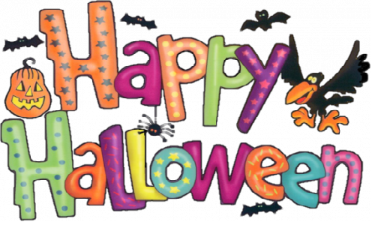

Halloween is so much fun because it's not like other nights of the year. Have fun and stay safe by following these tips:

See and Be Seen!
After dark, kids aren't usually swarming the neighborhood. But on Halloween night, they are. That's why kids need to watch out for cars and other traffic. Be sure that your mask or costume doesn't cover your eyes or make it tough for you to see where you're going. You might think about wearing makeup instead of a mask. If you do wear a mask, make sure the eye holes are big enough that you can see.
Kids also need to be seen on Halloween, so it's a good idea to wear or carry something that glows in the dark. You might choose a glowing necklace, a glow-in-the-dark treat bag, or a flashlight. Your parents also can apply reflective tape to your costume.

Don't Trip!
You want your costume to look cool, but there's nothing cool about tripping and stumbling all Halloween night. Make your costume trip-proof by: making sure it's not too long wearing shoes that fit
avoiding swords, canes, and other props that can get in your way
Don't Go It Alone
It's best to trick-or-treat with family members or friends. And it's also a good idea to have a grownup with you. A cell phone can be another handy item to have along. That way, you can check in with a parent or call for help, if needed.
Talk it over with your mom or dad when you're deciding where to trick-or-treat. Sticking close to home is great because then you'll know many of the people and you won't get lost in unfamiliar neighborhoods. And people who already know you just might throw an extra treat in your bag!
When trick-or-treating, avoid going inside a stranger's home. Sometimes a person might invite you in for a treat, but you can just say that your mom or dad asked you not to go inside anyone's house. (Likewise, never go up to or into a stranger's car even if the person offers you a Halloween treat.)
And if you're wondering about whether to go to a certain house, check if the porch light is on. If not, that's usually a sign that they aren't home or they don't want any trick-or-treaters.

Let's Talk Treats
Before you start eating the treats in your bag, you'll want to get a good look at them. When you get home, dump everything out and let your mom or dad see what you have. They can help you get rid of stuff you shouldn't eat. For instance, you don't want to eat anything that's loose or not in a wrapper. Anything unwrapped, including fresh fruit, should be thrown away. Without a wrapper, it's hard to tell if food is clean and safe to eat.
Once you've looked over your treats, you'll probably wonder just how much you can eat. Well, it's best not to overdo it. If you don't eat too much on Halloween, you'll have leftovers to enjoy in the days and weeks to come. In other words, you can make Halloween a little sweeter by making it last a little longer!
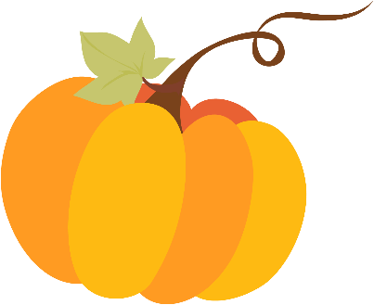

Halloween Jokes For Kids

Why don't angry witches ride their brooms? They're afraid of flying off the handle
Who won the skeleton beauty contest? No body
What do skeletons say before they begin dining? Bone appetit!
Where do baby ghosts go during the day? Dayscare centers
Who did Frankenstein take to the prom? His ghoul friend
What's a monster's favorite play? Romeo and Ghouliet
What do witches put on their hair? Scare spray
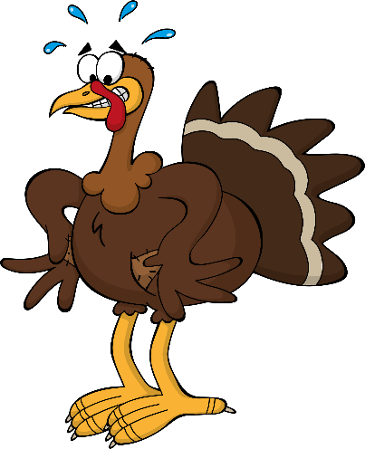

Here turkey, turkey, turkey
Turkeys are able to adapt to a wide variety of habitats. However, most turkeys are found in hardwood forests with grassy areas.

The best time to see a turkey is on a warm clear day or in a light rain.

They what?
Turkeys have heart attacks. When the Air Force was conducting test runs and breaking the sound barrier, fields of turkeys would drop dead.

Turkeys can drown if they look up when it is raining.

Eat, sleep, gobble
Turkeys spend the night in trees. They fly to their roosts around sunset.
Turkeys fly to the ground at first light and feed until mid-morning. Feeding resumes in mid-afternoon.
Gobbling starts before sunrise and can continue through most of the morning.

Eyes in the backs of their heads?
A wild turkey has excellent vision and hearing. Their field of vision is about 270 degrees. This is the main reason they continue to elude some hunters.
And they're fast, too!
A spooked turkey can run at speeds up to 20 miles per hour. They can also burst into flight approaching speeds between 50-55 mph in a matter of seconds.
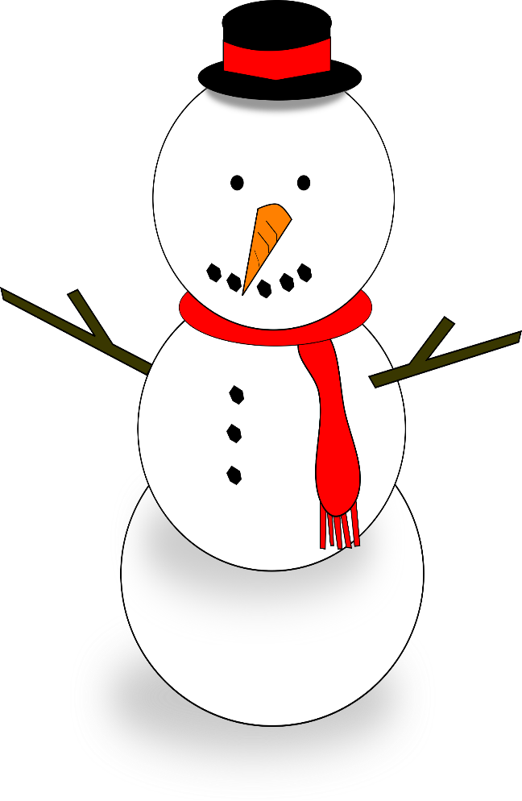
Holiday Schedule:
Thanksgiving/Day After. Thursday and Friday November 26 & 27, 2026 Closed
Thursday December 24, 2026 Christmas Eve Closes early at 12:30 pm and Friday December 25, 2026 Closed.

Friday January 1, 2027 New Year’s Day Closed.

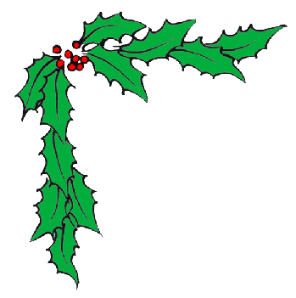
Christmas
Program

Mark your calendars! The Firefly Preschooler’s will be performing their annual Christmas Program Monday December 14, 2026 at 4:00 p.m.

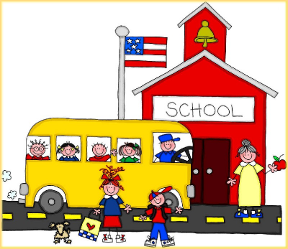

School Age News
Just a word regarding the children who attend elementary school. Parents are encouraged to keep an eye on the schooler’s bulletin board where we post many important memos. One being the sign-up sheets for a no school day. We usually post a sign-up sheet for those children planning on attending a full day at the center. Remember, if you sign your children up to attend the center, you will be responsible for payment on those no school days. We plan in advance for extra food and staffing to ensure your child’s needs are met.
Please remember to sign your child in and back out on the sign in sheet daily. We ask that parents sign their children in and not allow their children to sign these documents. The documents can and have been reviewed by various state and local offices. We feel so fortunate to have such awesome parents, we thank you in advance for your support and cooperation.

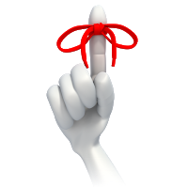

POLICY REMINDERS
~When you see a “note” taped to your child’s cubby please make sure you read and respond to that correspondence.
~We would also like to remind parents that you pay for your child by the week, not by the day. So, if a holiday falls on the weekday you will pay for the entire week.
~If inclement weather necessitates closing of the Center, announcements will be made on the Center’s answering service. We try and keep our doors open the best we can, however, if Southeast Polk Schools are closed it is a good indicator to call the Center. We are not necessarily closed when they are but it is a guideline for you to follow.
~ Medications are given at the Center; however, proper labels will be required (by the physician or pharmacist if the medication is a prescription) or clearly marked on the bottle/container for non-prescription medications, you cannot bring medication in syringes or placed in baby bottles. Parents need to complete a medication form prior to the staff dispensing the medication. Thanks!

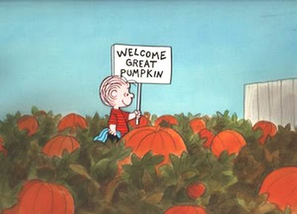

HALLOWEEN PARTY
We have scheduled our annual “Halloween Party” Friday October 30, 2026.

If you would like your child to dress up for our party please have your child dressed in their costume when they arrive at school. Also, please bring a change of clothing for the staff to change your child into around 10:30 am. Please remember that the Center DOES NOT promote violence so please keep your child’s costumes neutral.

Your child may bring candy if they wish to share with others.


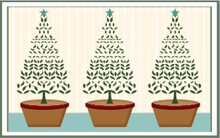

Christmas Parties!
Another date to remember!
Friday December 18, 2026.
Each class room will have their own individual Christmas party this year! Children may bring treats if they wish to share with their friends! (6wks-Fireflies).


Autumn/Winter Clothing

Cooler weather is rapidly approaching! Ugh! With this in mind we want to encourage our parents to dress their children accordingly. Just a

reminder, if the child is well enough to be at the
Center, the child is assumed well enough to go outdoors. We have policies and procedures in place to determine if the weather conditions are acceptable for outdoor play.
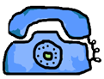

Telephone Calls:
Unless it is an emergency to talk with our staff, we ask that you call between the hours of 12 noon – 5:30 pm. Our staff is so busy during the morning hours, especially during preschool that to answer the phone is very distracting to the children.
Thank you so much for your understanding!

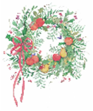~Thank You ~
Ms. Vickie and I would like to express our appreciation to all of our parents and family members for your encouragement and support this past year. We truly have enjoyed having your child here at our Center and feel honored to be your chosen Daycare /Preschool.

Your business is very much appreciated, and we will do our very best to continue to meet your childcare needs.

Your continued patronage and suggestions are a vital part of our growth. And for that, we are most grateful.

Thank you again! We look forward to serving your family for years to come.

Ms. Victoria L. Johnson
&
Ms. Cynthia R. Thompson


We’re on the Web!
See us at: nanniesunlimitedchildcare.com
Please look for our next newsletter January 2027

